Feed Forward: AI-Based Social Food Redistribution Platform
Yerav Aaron Charan
School of Computer Science and Engineering Vellore Institute of Technology, Chennai Email: yeravaaron.charan2023@vitstudent.ac.in

Abstract—Food wastage is a significant global issue while millions of people suffer from hunger. This paper presents “Feed Forward”, an AI-based social food redistribution platform that connects food caterers, restaurants, and NGOs to efficiently distribute leftover food. The system enables organizations to access surplus food at minimal cost while allowing food providers to reduce waste and generate revenue. The platform leverages web technologies, databases, and cloud storage to ensure real-time data availability and efficient coordination. The proposed system aims to create a sustainable ecosystem for food redistribution and social welfare.
- Cloudinary is used to store food images.
- AI/ML components analyze trends and optimize distribution.

B. Novelty
- Monetization of leftover food
- Real-time food availability tracking
- Integration of cloud storage for scalability
- AI-driven optimization for food distribution

  - Introduction
Food wastage and hunger are two contrasting problems that exist simultaneously. Large quantities of food are wasted daily by restaurants and catering services, while many individuals lack access to proper nutrition. Traditional food donation systems lack efficiency, coordination, and real-time data sharing. With the advancement of technology, it is possible to build platforms that bridge the gap between food providers and needy communities. Feed Forward aims to provide a structured
and scalable solution to redistribute surplus food effectively.
  - Problem Statement
The problem addressed in this project is the inefficient management of surplus food. Existing systems do not provide a unified platform to connect food providers with organizations that require food. Key challenges include:
- Lack of real-time information on available surplus food
- Poor coordination between restaurants and NGOs
- Food wastage due to logistical inefficiencies
- Limited accessibility for organizations to obtain low-cost food

- System Architecture

The system is divided into multiple layers:
- Frontend Layer: Developed using HTML and CSS for user interaction.
- Backend Layer: Flask-based server handling requests and sessions.
- Database Layer: MySQL for storing user and food data.
- Cloud Layer: Cloudinary for image storage.

III. Proposed System
Feed Forward is a web-based platform that connects restaurants, caterers, and NGOs to facilitate food redistribution.
A. Workflow
- Restaurants and caterers upload details of leftover food.
- The system stores data in a centralized MySQL database.
- NGOs and organizations browse available food in realtime.
- Users place orders based on availability and location.
- The system ensures smooth communication and order processing.

Fig. 1. System Architecture of Feed Forward
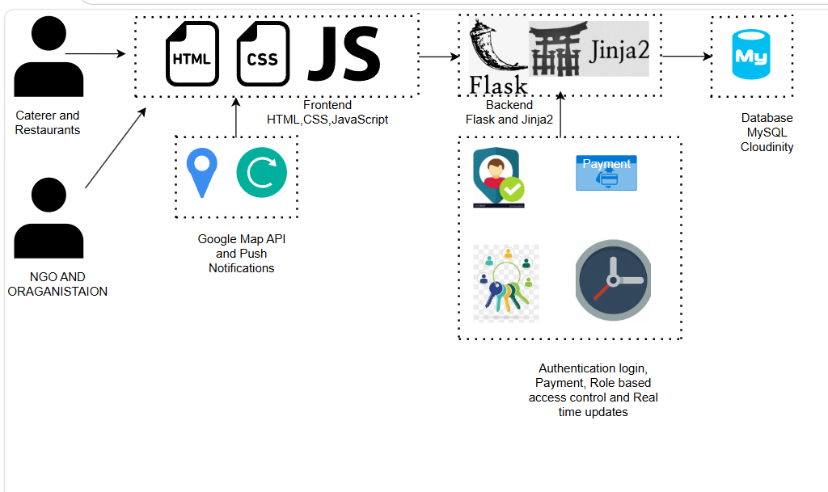

architecture.png

- Protocol Stack
The system follows a layered protocol model:
- Application Layer: Web interface and user interaction.
- Transport Layer: HTTP/HTTPS communication.
- Network Layer: Internet-based communication.
- Data Layer: MySQL database for structured storage.
- Cloud Layer: Cloudinary for image management.
- Testbed / Experimental Setup
- Tools Used
  - Frontend: HTML, CSS
  - Backend: Flask (Session-Based Authentication)
  - Database: MySQL
  - Cloud Storage: Cloudinary
- Dataset
  - Real-time food data uploaded by restaurants
  - Includes food type, quantity, price, and availability
- Environment
  - Localhost development environment
  - Browser-based testing
  - API testing using Postman
- Implementation Results
The system successfully demonstrates:
  - Real-time listing of leftover food
  - Efficient order placement by NGOs
  - Secure session-based authentication
  - Image handling using cloud storage
- Conclusion
Feed Forward provides an innovative and scalable solution to address food wastage and hunger simultaneously. By connecting food providers with NGOs through a digital platform, the system ensures efficient redistribution of surplus food. The integration of modern technologies such as cloud storage and AI enhances system performance and usability. This project demonstrates the potential of technology-driven social impact solutions.
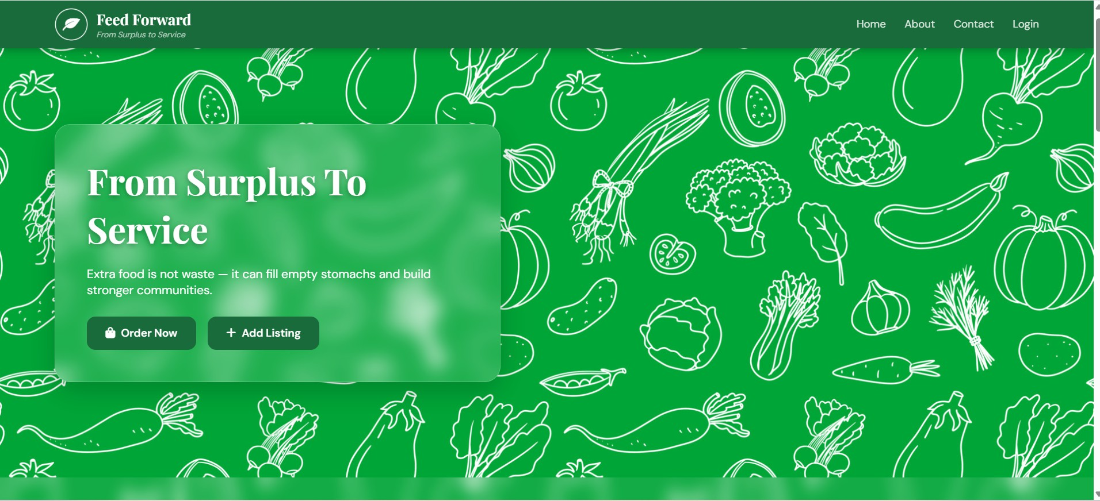

Fig. 2. Landing page of FeedForward



Fig. 3. Login Page
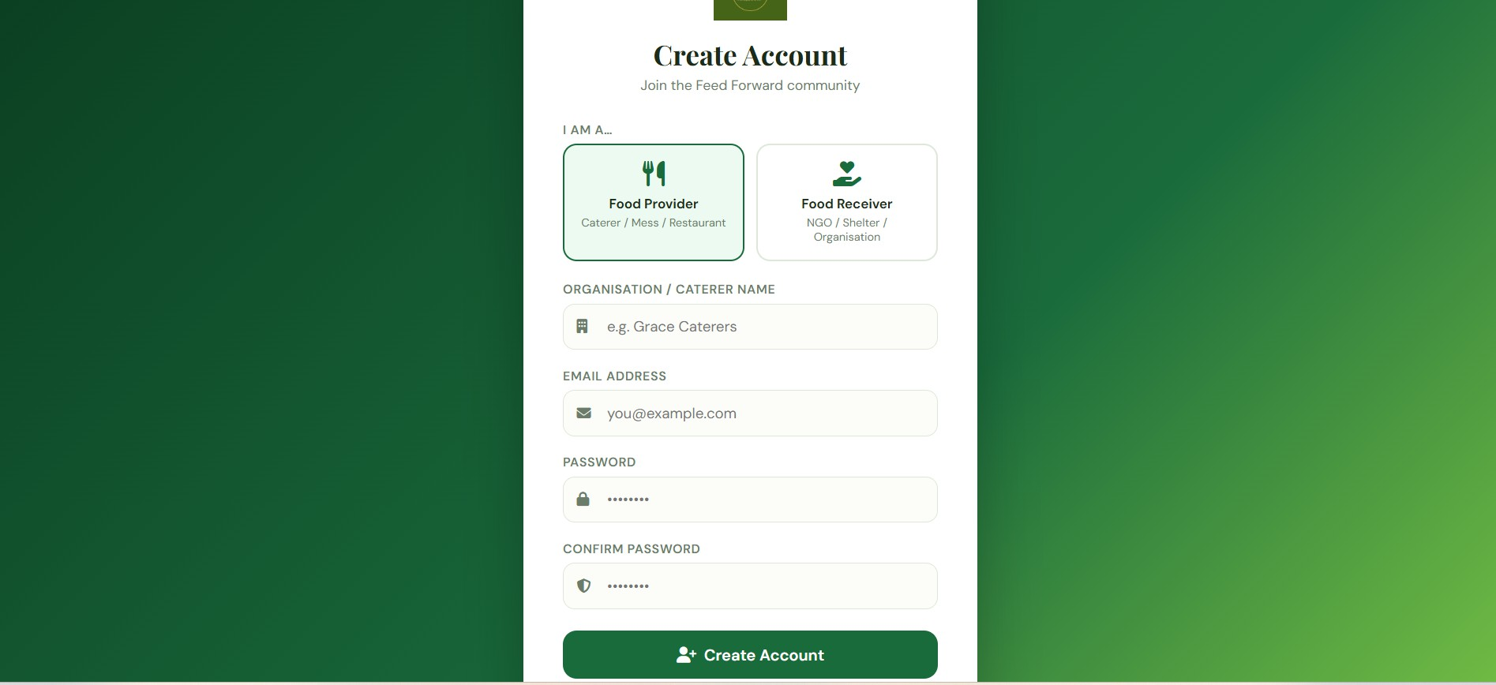

Fig. 4. Sign Up Page
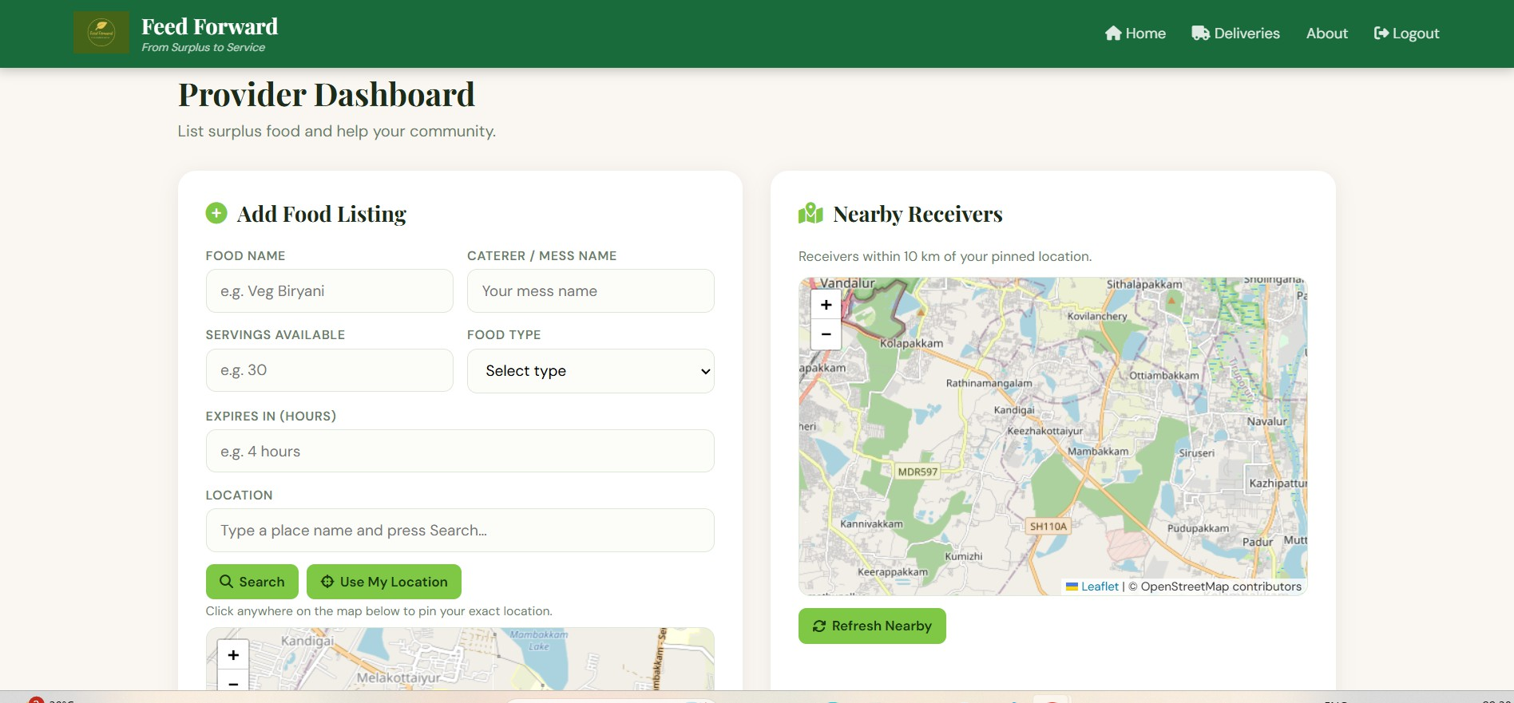

Fig. 5. Provider Add Food Page
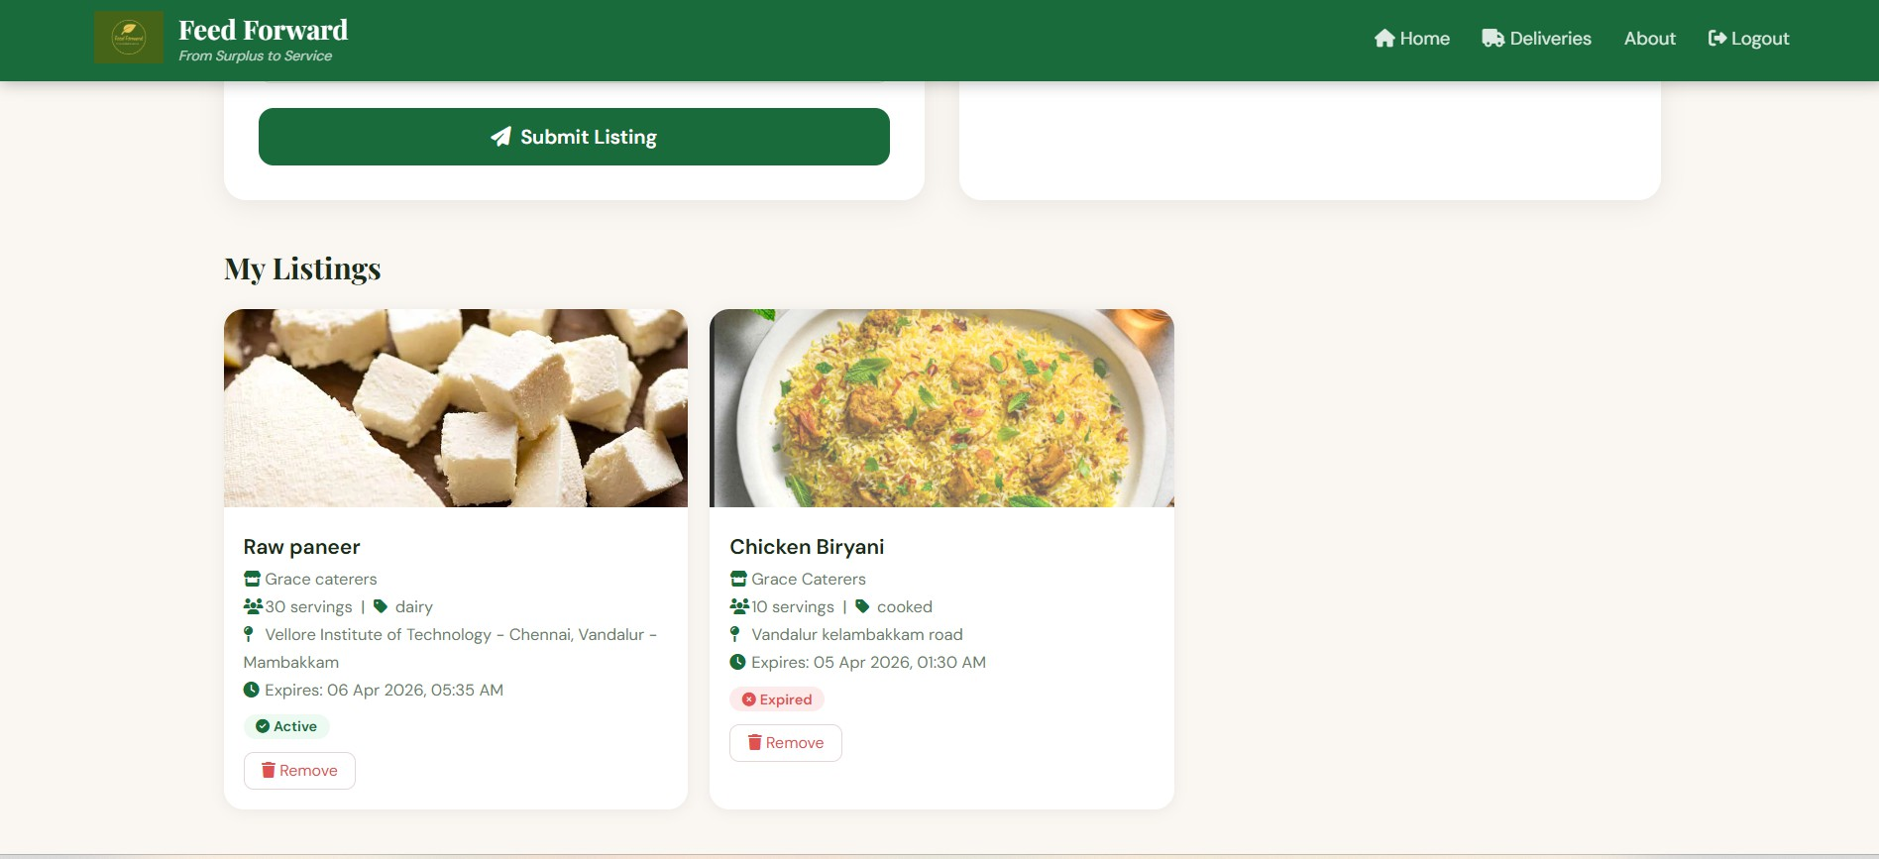

Fig. 6. Provider Add Food Page
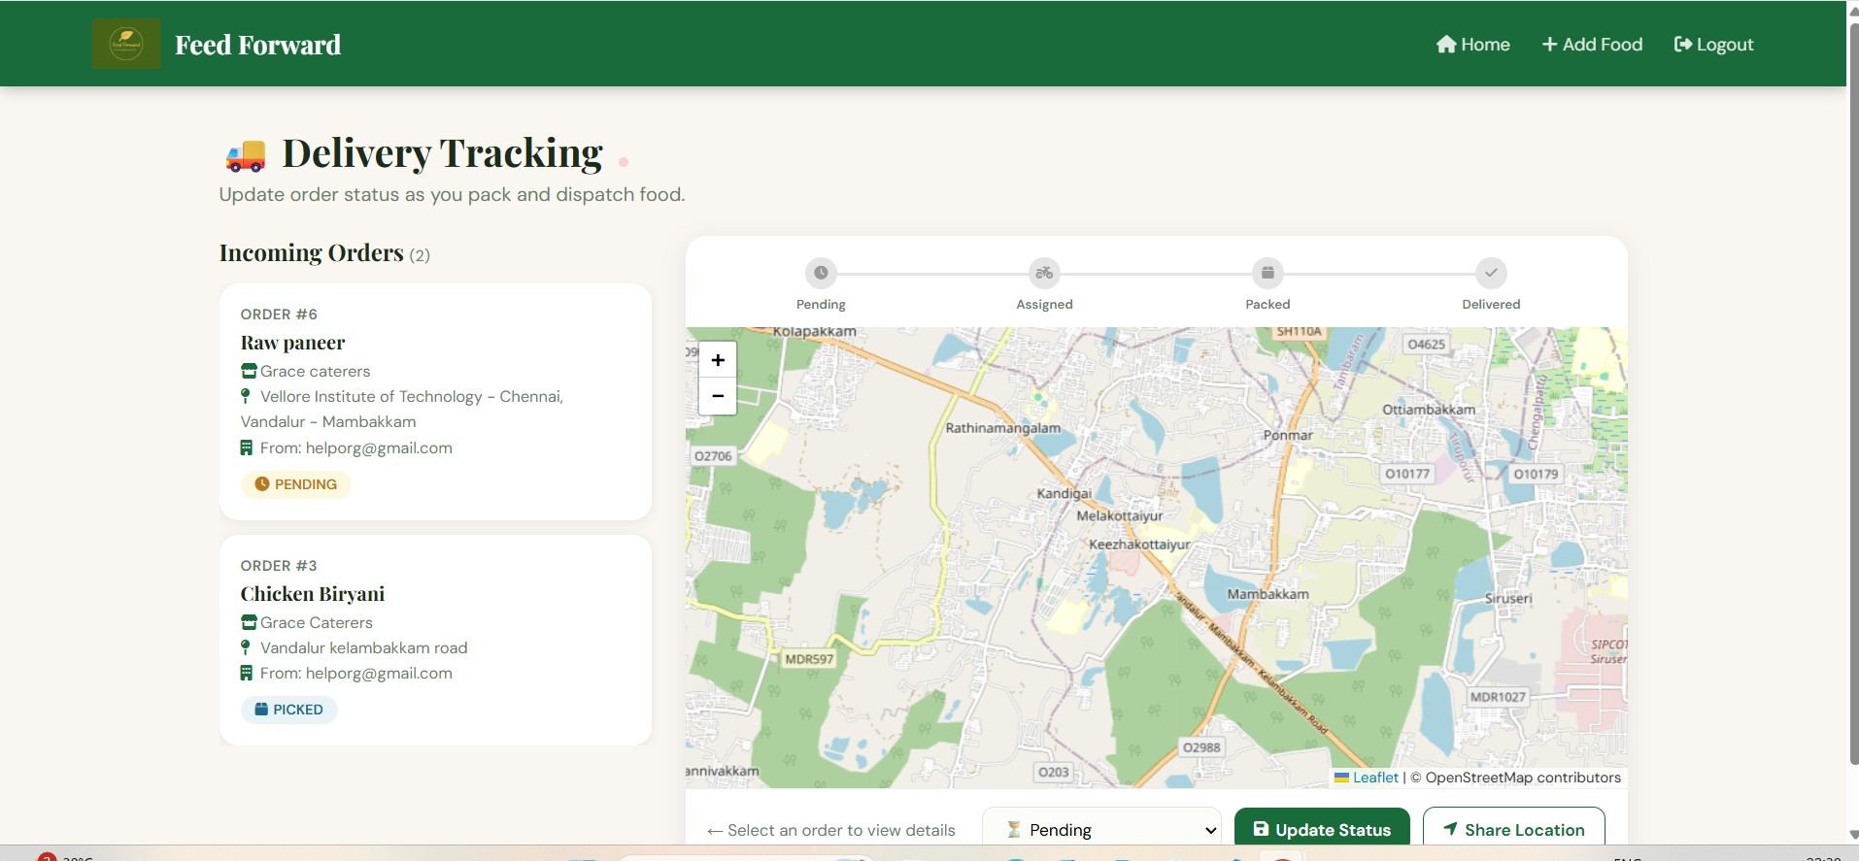

Fig. 7.Organisation delivery page

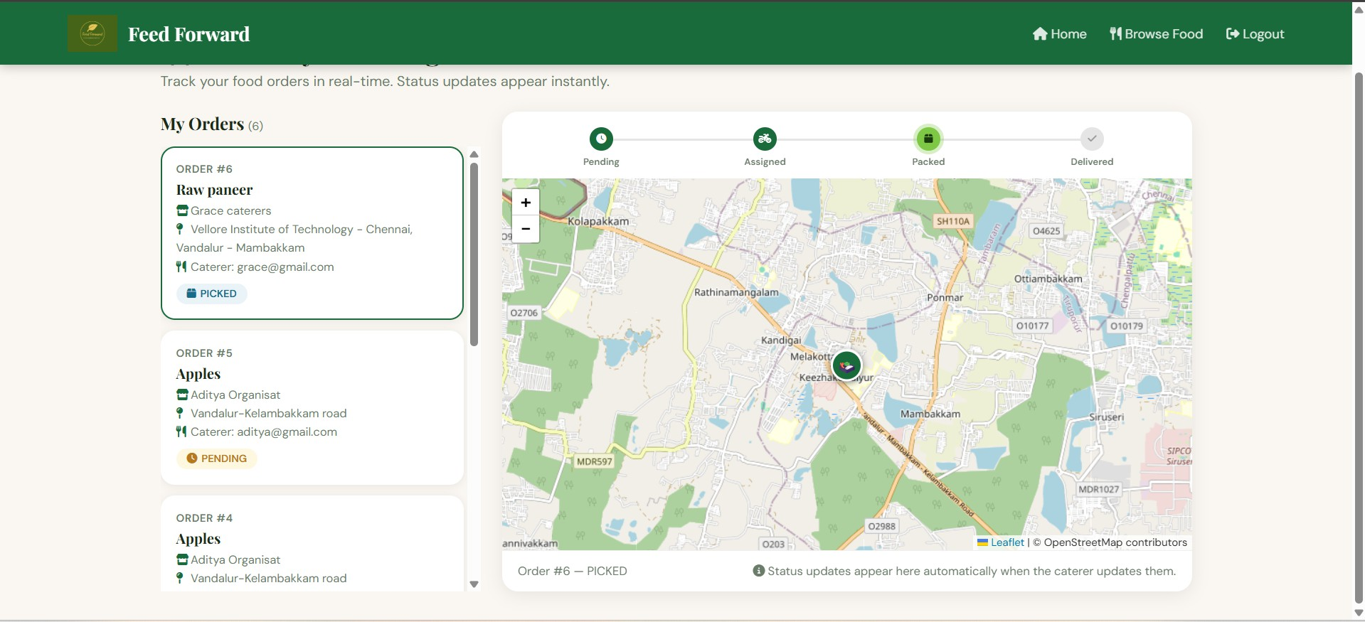

Fig. 9. Notification alert
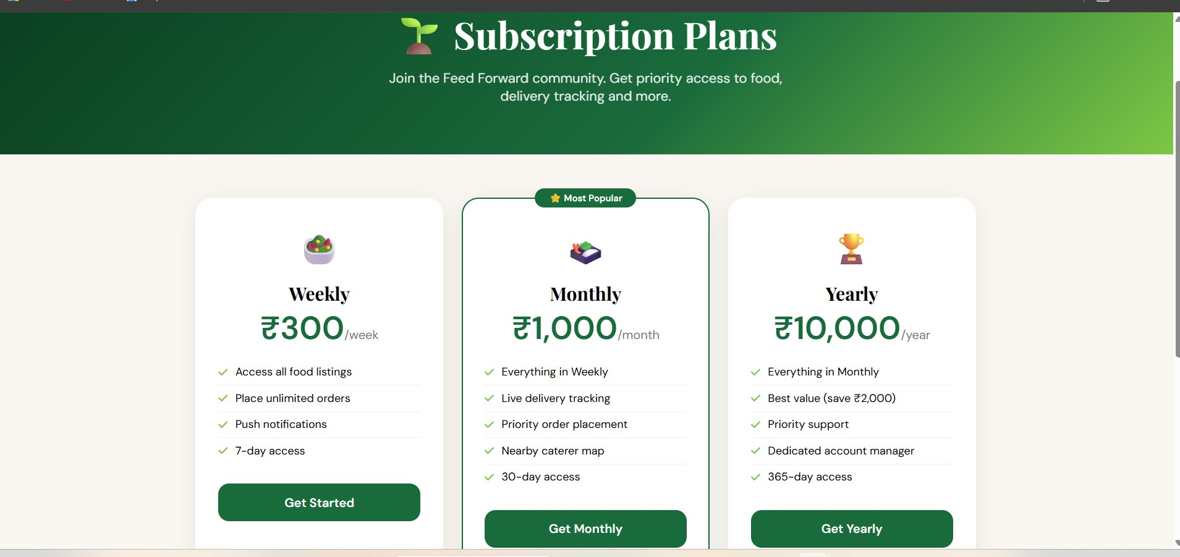

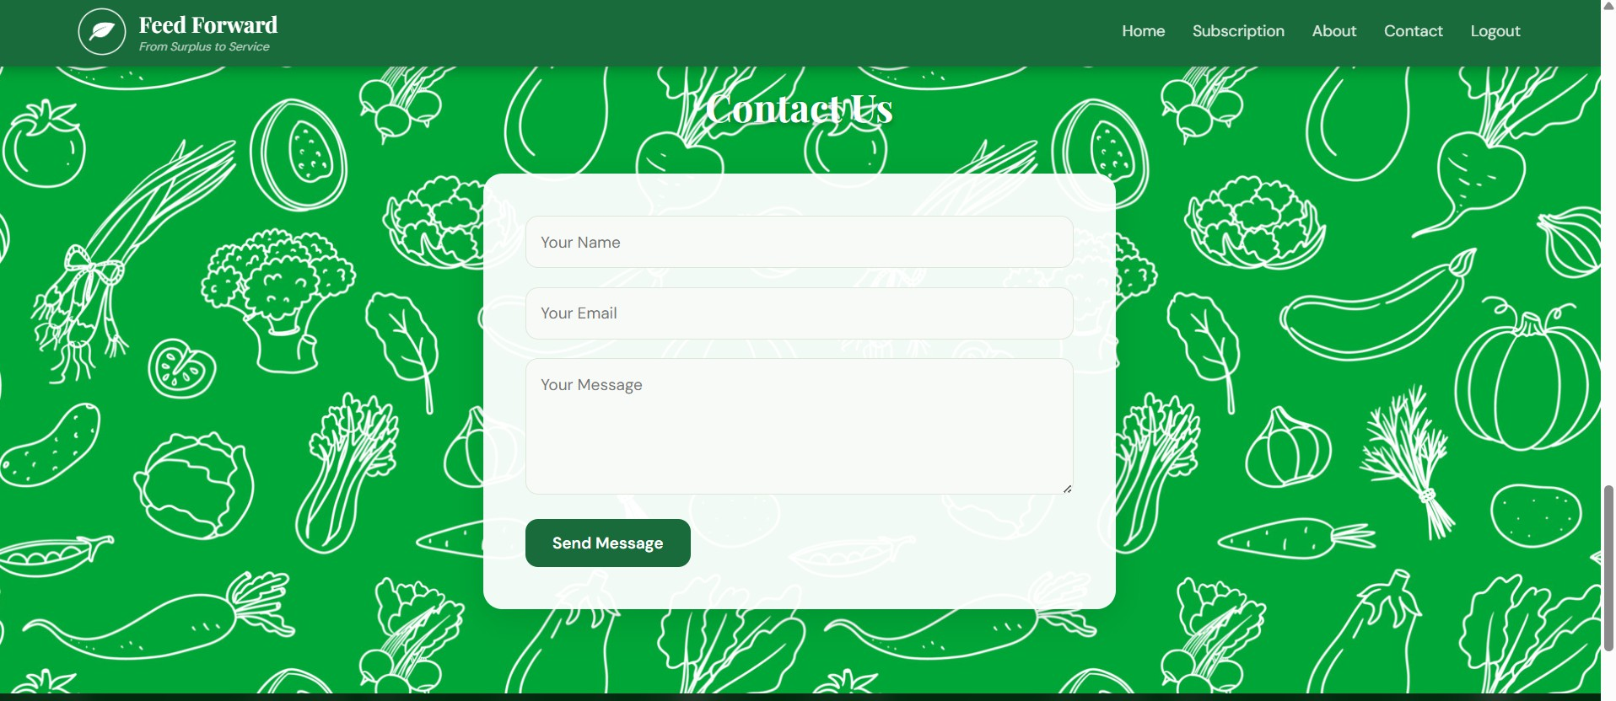
Fig. 10. Subscription page

Fig. 11. Contact page
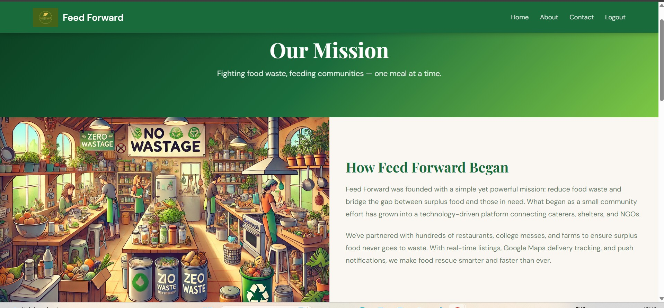

Fig. 12. About us page

